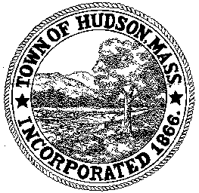

CONSERVATION COMMISSION
78 Main Street, Hudson, MA 01749
(978) 562-2020

Paul Byrne, Chairman W. Minot Wood, Vice Chairman David Esteves, Member

Terrence Joyce, Member Leif Longtine, Member Joseph Rodrigues, Member Al Tashian, Member

Meeting Minutes
October 21, 2010
- Preliminaries
  - Meeting called to order at 7:00 PM
  - Roll Call: Al Tashian, Terrence Joyce, Paul Byrne, Joe Rodrigues, Leif Longtine

2.0 Hearings and Appointments
2.1 RDA 401
Applicant: Michael Wade
Location: 34 Causeway Street
Project Description: Removal of 4 trees
Paul motioned to issue a Negative determination provided the roots were not dug out. Motion was seconded by Leif. Motion carried with all in favor 5-0

2.2 DEP 190-555
Applicant: Town of Hudson
Location: Houghton Court
Project Description: Reconstruction of Houghton Court including roads and sidewalks. Replacement/rehabilitation of the existing utilities infrastructure (water, sanitary sewer and storm drain). The work will include new street lights and electric conduits.
Paul motioned to close the public hearing and issue an Order of Conditions when the DEP file number is assigned. Motion was seconded by Al with all in favor
5-0

2.3 DEP 190-518
Applicant: Town of Hudson
Location: 29 Church Street
Project Description: Landscaping plan
Paul motioned to accept an amendment to the original landscape plan to correct disturbed area. The silt barriers are still in place. The property will be seeded with winter rye grass next week. The design plan will be presented the first week of March. Motion was seconded by Terrence with all in favor 5-0.

2.3 Update on Highland Commons tabled

2.4 Request for Review and Comments
1 Kane Industrial Drive
The project must have oil and grease traps in the floor drain. The containment area must be at 110% for waste products or any hazardous waste.

3.0 Adjournment
Meeting was adjourned at 8:00 PM

